BILKENT UNIVERSITY ENGLISH LANGUAGE PREPARATORY PROGRAM MATERIALS DESCRIPTION FORM

THEME: Unit 1 Social Psychology | TITLE OF THE MATERIAL:U1 Vocabulary Revision

Please tick the course package the material will be used in.
- Q Skills Intro | ¨

SKILL: Vocabulary | OBJECTIVE(S) (Tick and fill in as appropriate) Students will be able to  - Practice Unit 1 words

Prepared by: ELPP Instructors

Exercise 1: Write the number of each picture next to the correct word.
Player ........1........... Cycling ....................
Musician ................. Painting ...................
Conversation .......... Chart ........................
Field ....................... Week ........................
Soccer ................... Lake .........................

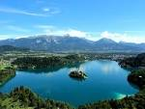
1 2 3

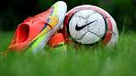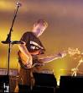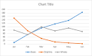
4 5 6 7
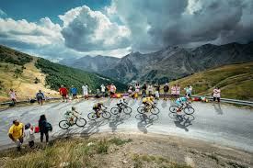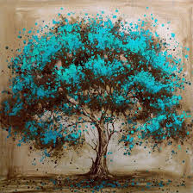
8 9 10

Exercise 2: Complete the sentences by using the words above.
- My favorite sport is .............................
- He is a very good football ................................
- She plays the guitar well. She is a professional ....................
- The ..................... between the teacher and the student was useful.
- We went to the ................... at the weekend.
- What are your travel plans for the next ................ ?
- This ..................... belongs to Vincent van Gogh.
- You can see the results in the ......................
- You can grow vegetables in this .........................
- Let’s go ............................ this weekend.

Exercise 3 : Make a sentence with the verbs below.
- Ask..............................................
- Listen ...........................................
- Meet..............................................
- Play .................................................
- Read .................................................
- Speak .................................................
- Take .......................................................
- Tell ............................................................
- Write ........................................................
- Hear ............................................................

